## 

## **IPO Analyser**

**Project Report submitted in the partial fulfilment**

**Of**

**MBA.Tech**

**In**

**Computer Engineering**

By

Atharva Goswami(A059)

Alaap Varma(A077)

Lishiv Sharma(A079)

Parth Agrawal(A100)

Under the supervision of

**Dr. Sandip Bankar**

(Professor, Department, STME)

SVKM’s NMIMS University

(Deemed-to-be University)

#### SCHOOL OF TECHNOLOGY MANAGEMENT & ENGINEERING(STME)

Kharghar, Navi Mumbai

(2024)

**CERTIFICATE**



This is to certify that the project entitled **(“IPO Analyser”)**, has been done by **Mr. Atharva Goswami, Mr. Alaap Varma, Mr. Lishiv Sharma, Mr. Parth Agrawal** under my guidance and supervision & has been submitted in partial fulfilment of the degree of **MBA.TECH** in **Computer Engineering** of STME, SVKM’s NMIMS (Deemed-to-be University), Kharghar, Navi Mumbai, India.

Project mentor (name and Signature) Examiner ( name and Signature)

(Internal Guide)

**Date**

**Place: Mumbai**

**(HoD)** (name and Signature)

**Acknowledgement**

We would like to extend our sincere gratitude to Dr. Sandip Bankar, our esteemed mentor, whose guidance, expertise, and unwavering support have been invaluable throughout the duration of this project. Dr. Bankar’s insights and encouragement significantly contributed to its success. We are also deeply thankful to Prof. Aditya Kasar, the Head of the Department, for his continuous encouragement and for providing an environment conducive to learning and innovation.

This project, titled "IPO Analyser" would not have been possible without the collective support and encouragement from both Dr. Bankar and Prof. Kasar. Their mentorship has been instrumental in shaping our academic journey and enhancing our understanding of the subject matter.

We would also like to thank our college, SVKM’s NMIMS (Deemed-to-be University), Navi Mumbai, India, for giving us the opportunity and the environment to learn and grow. We are grateful to have had the opportunity to work under their guidance and leadership.

Student Names

|  |  |  |
| --- | --- | --- |
| **NAME** | **ROLL NO.** | **SAP ID** |
| Atharva Goswami | A059 | 70472019184 |
| Alaap Varma | A077 | 70472019446 |
| Lishiv Sharma | A079 | 70472019450 |
| Parth Agrawal | A100 | 70472019556 |

**Abstract**

An initial public offering (IPO) marks a major turning point in a company's trajectory, marking its transformation from a private company to a publicly traded entity. Investors looking to capitalize on their IPO opportunities face many obstacles, including the flood of information, the inherent volatility of the market and the complexity of financial analysis. To address these challenges, this research paper proposes an innovative framework that uses the latest technology and established financial methodologies to provide investors with actionable insights to make informed investment decisions in the IPO environment. Our carefully designed approach includes a wide range of data. sources and sophisticated analysis tools. Resources like yfinance, Beautiful Soup and the Financial News API allow investors to delve into the IPO environment by providing access to real-time market data, comprehensive competitor analysis and key macroeconomic indicators. Financial analysis is a cornerstone. of our method. We use advanced techniques such as anomaly detection, careful ratio calculation and rigorous peer review. Using Python libraries such as NumPy, we achieve simplified data processing and analysis that allows investors to identify key performance indicators and carefully assess the financial well-being of potential IPO candidates. To complement the quantitative analysis, our study provides a robust qualitative. analysis analysis a framework that recognizes industry dynamics, firm size and geographic presence as key factors influencing investment decisions. Using a balanced approach, we carefully consider qualitative aspects such as strong revenue growth, demonstrable profitability, and experienced management. With this in-depth analysis, we provide investors with a comprehensive view of IPO opportunities. A key part of our research is the development of a custom artificial intelligence (AI) model tailored specifically for business development. This model provides actionable insights to investors using machine learning algorithms and natural language processing techniques. Extracting valuable insights from financial data, news articles and sentiment analysis, the model allows investors to anticipate market trends, proactively identify potential risks and take advantage of profitable returns. In addition to providing useful investment insights, our research also addresses. theoretical bases. Using the BHAR (Buy and Hold Abnormal Returns) framework. By carefully evaluating long-term performance against established benchmarks and carefully weighing factors such as terminal growth value and capacity premium, investors can better understand an IPO's intrinsic value and its future growth potential. In addition, our research underscores its importance interactive tools and visualization techniques to improve investment decision making. By adding web frameworks, comprehensive benchmarking tools and Monte Carlo simulations, we provide users with intuitive user interfaces and dynamic graphics. These tools allow investors to explore different investment scenarios, perform sensitivity analysis and make informed investment choices with greater confidence.

**Table Of Contents**

|  |  |
| --- | --- |
| **Topics** | **Page** |
| List of Figures | 4 |
| List of Tables | 5 |
| **Chapter 1 Introduction** | **8** |
| 1.1 Background of the project topic | 8 |
| 1.2 Motivation and scope of the report | 9 |
| 1.3 Problem statement | 11 |
| 1.4 Salient contribution | 11 |
| 1.5 Organization of report | 12 |
| 1.6 Model Selection and architecture | 13 |
| 1.7 Benefits and Objectives | 15 |
| **Chapter 2 Literature Survey** | **16** |
| 2.2 Exhaustive literature survey | 17 |
| **Chapter 3 Methodology and Implementation** | **24** |
| 3.1 Block diagram | 24 |
| 3.3 Software description, flowchart / algorithm | 25 |
| **Chapter 4 Results and Analysis** | **28** |
| 4.1 Results | 28 |
| 4.2 Analysis | 30 |
| **Chapter 5 Advantages, Limitations, and Applications** | **34** |
| 5.1 Advantages | 34 |
| 5.2 Limitations | 36 |
| 5.3 Applications | 38 |
| **Chapter 6 Conclusion and Future Scope** | **40** |
| 6.1 Conclusion | 40 |
| 6.2 Future Scope | 42 |

**List of Figures**

|  |  |  |
| --- | --- | --- |
| **Fig No** | **Name of the figure** | **Page No** |
| Fig 1.6.1 | Architecture of GRU | 14 |
| Figure 3.1.1: | Block Diagram | 24 |
| Figure 3.1.2: | Working Flowchart | 25 |
| Figure 3.3.3: | Interface of News API | 26 |
| Figure 3.3.4: | Interface of NSEpy | 26 |
| Figure 3.3.5: | Interface of Google Colab | 27 |

**List of Tables**

|  |  |  |
| --- | --- | --- |
| **Table No** | **Name of the Table** | **Page No** |
| 1 | Exhaustive Literature Survey | 17 |

**Chapter 1**

**Introduction**

* 1. **Background of the Project**

An initial public offering (IPO) is a pivotal moment for companies, marking their transformation from private entities to publicly traded players in the global financial arena. For investors, IPOs offer an attractive opportunity to participate in the early growth of promising companies that can bring significant returns. But this charm is not without its challenges.

The risks associated with IPOs are multifaceted. Limited historical data on new stock companies makes financial analysis a difficult task. Market volatility adds uncertainty to the equation, as investor sentiment can change dramatically due to a number of factors, from business cycles to geopolitical tensions. The process of valuing these young companies is further complicated by the fact that traditional methods may not fully exploit their future potential.

The memory of historical market swings is a stark reminder of the volatility associated with IPOs. The dot-com bubble of the late 1990s, fueled by an unbridled boom in Internet businesses, led to a spectacular crash in which many investors suffered heavy losses. Similarly, the global financial crisis of 2008 highlighted the interconnectedness of financial markets and the vulnerability of IPOs to a broader economic downturn. These events have led to increased regulatory scrutiny and a more cautious approach to IPOs.

Despite these challenges, IPOs continue to attract significant investor interest. The potential for high returns, especially for companies with innovative and disruptive technologies, continues to be a strong attraction for investors. However, evaluating and choosing suitable IPO investments is a complex dance that requires investors to consider many different factors.

Traditionally, investors rely on a combination of quantitative financial analysis, careful evaluation of company fundamentals and a healthy dose of. from market intuition to navigating IPOs. However, the explosion of technology and the explosion of data sources have opened the doors to new and innovative approaches to improve the IPO investment decision-making process.

This study examines the complexity of IPOs and attempts to address both challenges. and the opportunities they offer. We provide a comprehensive framework that uses advanced financial analysis techniques, insights based on artificial intelligence (AI) and qualitative factors that influence investment decisions. By integrating these elements, our research aims to equip investors with the necessary tools and knowledge to make informed decisions in the dynamic and competitive IPO market. Ultimately, this framework aims to enable investors to maximize their returns while effectively reducing the risks associated with IPO investments.

* 1. **Motivation and Scope of report**

The appeal of initial public offerings (IPOs) lies in their potential for a significant return on investment by providing investors with early access to promising companies. However, this appeal is tempered by the complexity and challenges of navigating the IPO landscape. Unlike established publicly traded companies, IPOs present a unique set of risks because historical data is limited for in-depth financial analysis. Market volatility further complicates the equation, as investor sentiment can swing wildly due to a number of factors, from global economic changes to unexpected geopolitical events. In addition, accurate valuation of these young companies is often fraught with uncertainty, as traditional valuation methods may not be able to fully exploit their disruptive potential and future growth careers.

These challenges are exacerbated by historical market changes that are very similar. . The inherent volatility associated with IPOs. The dot-com bubble of the late 1990s, fueled by unbridled enthusiasm for Internet businesses, eventually led to a spectacular crash that left many investors with gigantic losses. Similarly, the global financial crisis of 2008 highlighted the interconnectedness of financial markets and the vulnerability of IPOs to a broader economic downturn. These events naturally led to increased regulatory oversight and a more cautious approach to IPOs.

Despite these significant challenges, IPOs continue to attract significant investor interest. Opportunities for high returns, especially in innovative companies with disruptive technology and the promise of exponential growth, continue to be a strong attraction for investors. However, evaluating and selecting suitable IPOs is a complex endeavour that requires investors to carefully consider various quantitative and qualitative factors.

Traditionally, investors rely on a combination of quantitative financial analysis, which is a rigorous assessment of a company's business performance. the basics and a healthy dose of intuition to navigate the IPO. However, the explosion of technology and the explosion of data sources have opened the doors to new and innovative approaches to improve the IPO investment decision-making process.

This study examines the complexity of IPOs and attempts to address both challenges. and the opportunities they offer. We provide a comprehensive framework that uses advanced financial analysis techniques, insights based on artificial intelligence (AI) and qualitative factors that influence investment decisions. By integrating these elements, our research aims to equip investors with the necessary tools and knowledge to navigate the dynamic and competitive IPO market with greater confidence. Ultimately, this framework aims to enable investors to maximize their returns while effectively mitigating the risks associated with IPO investments.

The scope of this report goes beyond traditional methods to include a multidisciplinary approach to IPO investment decision-making. This multifaceted approach includes quantitative financial analysis, qualitative factors, AI-based insights and established theoretical frameworks. Key parts of the report are:

1. 1. **Data intelligence:** We explore the use of various data sources such as yfinance, Beautiful Soup and the Financial News API to gather comprehensive market intelligence, competitor information and key macroeconomic indicators. Using advanced financial analysis techniques such as anomaly detection, careful ratio calculation and rigorous corporate benchmarking, we provide investors with a deeper understanding of the financial health and potential of IPO opportunities.
2. **Qualitative Considerations:** We examine qualitative factors such as industry dynamics company size and geographic presence as important factors. , which influence IPO investment decisions. Emphasizing key quality indicators such as strong revenue growth, proven profitability, and experienced management expertise, we provide investors with a holistic view of IPO opportunities, allowing them to go beyond just financial considerations.
3. **AI-based experiences:** We develop the cut.- Edge AI-powered model that uses machine learning algorithms and natural language processing techniques to extract valuable insights from various data sources. These sources include economic data, news articles and sentiment analysis. By providing actionable insights into market trends, potential risks and profitable investment opportunities, our model improves investment decision-making by empowering investors to make informed choices based on a broader and deeper understanding of the market.
4. **Theoretical Basis:** We adopt established theory. frameworks like buy and hold abnormal returns (BHAR) - A method for analysing long-term IPO performance against established benchmarks. By considering factors such as terminal growth value and capacity premium, we provide investors with a deeper understanding of an IPO's intrinsic value and long-term growth potential.
5. **Interactive tools and visualization:** understanding the importance of user-centricity and interaction in decision-making. -making -we emphasize the importance of interactive tools, visualization techniques and Monte Carlo simulations. With intuitive interfaces and dynamic charts, investors can explore different investment scenarios, perform sensitivity analysis, and ultimately make informed investment choices with confidence and a more detailed understanding of the potential risks and benefits of each IPO.
   1. **Problem Statement**

The problem statement of this study refers to the challenge of effectively navigating the complex challenges of the IPO market. Although IPOs offer promising opportunities to invest in early-stage, high-growth companies, they present unique challenges such as limited historical data, market volatility and the difficulty of conducting comprehensive financial analysis. Investors often face uncertainty and risk when evaluating IPO opportunities based on incomplete information and subjective judgments. This study seeks to address these challenges by developing a systematic framework that combines advanced financial analysis techniques, AI-based insights and qualitative factors to provide investors with the tools and information needed to make informed decisions in a dynamic and competitive IPO market.

* 1. **Salient Contribution**

The main contribution of this research is the development of a comprehensive framework that addresses the multifaceted challenges of listing. Combining advanced financial analysis techniques, AI-powered insights and qualitative factors, the framework provides investors with the tools and information needed to navigate the complexities of the IPO market. The main contributions are:

**1. Better decision-making:** Advanced financial analysis techniques and AI-powered insights enable investors to make more informed decisions about IPO investments, thereby reducing uncertainty and risk.

**2. Holistic Perspective:** Quality factors as an industry. dynamics, firm size and geographic presence provide investors with a complete picture of IPO opportunities, allowing them to comprehensively evaluate opportunities.

**3. Actionable insights:** AI-powered model development provides actionable insights into market trends and risk factors, as well as investment opportunities which allows investors to take advantage of profitable IPO opportunities and avoid potential pitfalls.

**4. Theoretical Frameworks:** This study adopts theoretical frameworks such as the BHAR (Buy and Hold Abnormal Return) methodology and provides a deeper long-term analysis. - The IPO's performance relative to benchmarks, which improves investors' understanding of the IPO's true value and growth potential.

**5. Practical Applications:** The integration of interactive tools, visualization techniques and Monte Carlo simulations facilitate practical application, allowing investors to explore different investment scenarios, perform sensitivity analysis and make informed investment decisions in real time.

* 1. **Organization of Report**

**Chapter 1:** **Introduction**

Presents an IPO program analysis framework that addresses IPO challenges using advanced financial methods and an AI perspective.

**Chapter 2:** **Literature review**

Explores existing research on IPO investment strategies, financial analysis techniques, and AI-based decision models.

**Chapter 3:** **Methodology and implementation**

details the proposed framework that integrates data sources, analytical tools and AI algorithms for IPO analysis.

**Chapter 4:** **Results and analysis**

Presents the results of applying the framework, evaluates IPO prospects and provides practical insights for investors.

**Chapter 5:** **Benefits**

highlights benefits, including holistic decision-making, real-time market insight, and advanced risk management in IPOs.

**Chapter 5:** **Limitations**

Discusses limitations such as data accuracy, model assumptions, and market volatility that affect IPO analysis.

**Chapter 5:** **Application**

Explores practical applications of IPO software analysis. . framework for investors. to address informed decision making in IPOs.

**Chapter 6:** **Conclusion**

summary of research findings that emphasize the importance of the proposed framework and its potential impact.

**Chapter 6:** **Future scope**

Suggests future research opportunities, including improvements to AI algorithms, expansion of data sources, and ethical considerations take note.

* 1. **Model Selection**

**In the context of our IPO analysis software using a Gated Recurrent Unit (GRU) offers us several advantages:**

**1. Efficiency in Training:** GRUs typically require fewer parameters compared to Long Short-Term Memory (LSTM) networks. This reduced complexity can lead to faster training times and lower computational costs, which is advantageous when dealing with large datasets or when training models in real-time, as is often the case in financial markets.

**2. Effective Handling of Long Sequences:** GRUs are well-suited for processing long sequences of data, such as financial time series or news articles. They can capture dependencies over longer distances in the sequence, which is crucial for understanding the context and trends in financial data and textual information.

**3. Reduced Risk of Overfitting:** With their simplified architecture, GRUs are less prone to overfitting compared to LSTMs, especially in scenarios where training data is limited or noisy. This is particularly important in financial analysis, where accurate predictions rely on generalizing patterns from historical data to unseen future events.

**4. Ease of Implementation:** Implementing GRUs is often simpler than LSTMs due to their fewer parameters and more straightforward architecture. This simplicity can streamline the development process, making it easier to experiment with different architectures, hyperparameters, and training techniques.

**5. Real-Time Analysis:** GRUs can facilitate real-time analysis of streaming financial data or news feeds. Their efficiency in processing sequential data allows for timely insights and decision-making, which is crucial in dynamic markets where conditions can change rapidly.

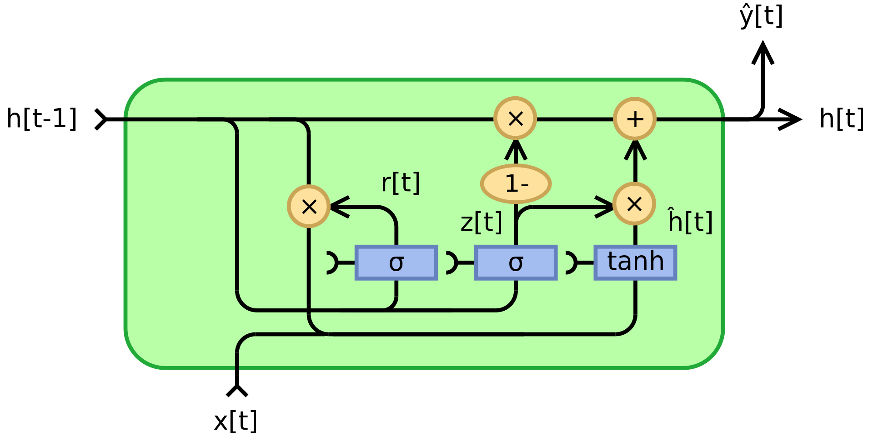

**Fig. 1.6.1 Architecture of GRU**

**Mathematical Equation for a fully gated unit is as follows:-**

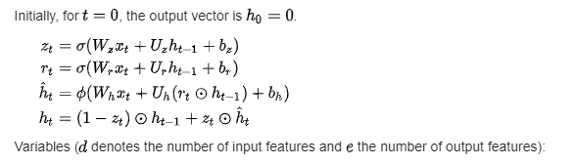

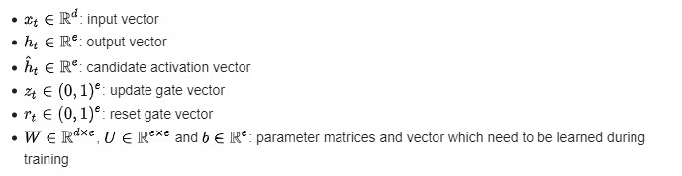

**Benefits of GRU over LSTM and RNN are as Follows:**

1. **Lower Memory Requirements:** GRUs typically have lower memory requirements compared to LSTMs. This advantage can be particularly beneficial when deploying models in resource-constrained environments, such as mobile devices or edge computing devices. With lower memory overhead, GRUs enable more efficient utilization of computational resources, making them well-suited for applications where memory efficiency is a concern.
2. **Reduced Vanishing Gradient Problem:** GRUs have been shown to mitigate the vanishing gradient problem more effectively than LSTMs. The vanishing gradient problem occurs when gradients become extremely small during backpropagation, leading to slow or ineffective learning. GRUs address this issue by using update gates to control the flow of information, allowing them to propagate gradients more effectively through time. As a result, GRUs can facilitate more stable and consistent training, leading to better convergence and performance in deep learning models, which is crucial for accurately capturing complex patterns in financial data and textual information.
3. **Simpler Architecture:** GRU has a simpler architecture compared to LSTM. It combines the forget and input gates into a single update gate, and merges the cell state and hidden state, reducing the number of parameters to learn. This simplicity can lead to faster training times and less computational overhead, which can be advantageous when dealing with large datasets or real-time analysis, as is often the case in financial markets.
4. **Faster Convergence:** Due to its simpler architecture, GRUs often converge faster during training compared to LSTMs. This can be beneficial when working with limited computational resources or when real-time analysis is required, allowing you to iterate and refine your models more quickly.
5. **Less Susceptible to Overfitting:** The reduced number of parameters in GRUs can make them less prone to overfitting, especially when dealing with limited training data, which is often the case in financial markets where historical data may be sparse or noisy.

**1.7 Objective**

Equip Investors with the necessary tools and knowledge to make informed decisions in the IPO market.

Maximize Investor returns while reducing risk associated with IPO Investments.

Develop a comprehensive framework that uses advanced financial analysis techniques.

Provide a deeper understanding of the financial health and potential of IPO through data intelligence.

Improve Investment decision-making by empowering investors with actionable insights based on a broader and deeper understanding of the market.

**Chapter 2**

**Literature Review**

**2.1 Introduction to overall topic**

Initial public offerings (IPOs) play a key role in capitalization and economic growth. Companies look to IPOs to raise money for expansion, acquisitions, and innovation. However, for investors, IPOs can be complex and potentially risky due to information asymmetry and limited post-IPO performance history.

This literature review aims to explore various aspects of IPOs, focusing on financial markets, software analysis techniques and their intersections. Here is a breakdown of the main areas of the survey:

**1. IPO performance and market dynamics:**

• Prior research on long-term IPO performance relative to the broader market.

• The impact of investor sentiment and market conditions on IPO performance and pricing.

• Underwriter reputation and analyst recommendations for IPO success.

• The impact of industry regulation IPO price in various sectors.

**2. Financial analysis and investment strategies:**

• Traditional financial measures used to evaluate IPOs, such as profitability, liquidity and performance

• The inclusion of environmental, social and governance (ESG) factors in IPO analyzes has increased.

• Alternative data sources (other than web scraping) opportunities to improve the accuracy of IPO.

• Development and use of machine learning models for IPO valuation and recommendation systems.

**3. User-centred software and decision support:**

• Principles for developing user-friendly software tools that enable individual investors to analyse.

• The importance of explanatory artificial intelligence models to increase transparency.

• The role of backtesting techniques in evaluating the performance of IPO algorithmic trading strategies.

• The greatest effect of frequency trading on the liquidity of IPO stocks.

**4. Innovations and emerging trends:**

• Exploring the possibilities of blockchain technology to revolutionize the IPO process for efficiency.

• The role of crowdfunding platforms in democratizing the access of small investors to IPO investments.

• Handling of cyber security. Risks associated with IPO prospects and their mitigation with risk.

**2.2 Exhaustive Literature Survey**

| Theme | Paper name | Authors | Year | Objective | Comments |
| --- | --- | --- | --- | --- | --- |
| Investment decisions | Financial Literacy, Risk Tolerance and Stock Market Participation | Rajesh Mishra (ICFAI Business School Gurgaon) | 2018 | To investigate the relationship between financial literacy, investment behavior, and risk propensity. | Addresses an important aspect of household finance with implications for policy and financial education. |
| Feature selection and outlier handling in classification tasks | A meta analysis study of outlier detection methods in classification | Edgar Acuna | 2004 | Investigate the impact of outliers on the performance of feature | compares four feature selection methods on datasets with and without outliers. Removing outliers generally improves classification accuracy. |
| Analysis of the determinants of Liquidity and Profitability Ratios before and after Initial Public Offering (IPO) in the context of financial management. | Determinants of Liquidity Ratio and Profitability Ratio: Analysis Before IPO and After IPO (Financial Management Review Literature). | Harry Pambudi. | 2022 | To explore the influence of pre-IPO and post-IPO conditions on a company's Liquidity Ratio and Profitability Ratio, providing insights for further research in financial management. | The paper offers a comprehensive review of literature, discussing the impact of IPO conditions on financial performance metrics, suggesting areas for future investigation. |
| Analysis of Underpricing and Overpricing of IPOs in India | A Study On Under Pricing and Over Pricing of IPOs in India | B. Haralayya and P.S. Aithal | 2021 | To examine factors influencing underpricing and overpricing of IPOs in India | Axis Bank as lead manager has most IPOs but underpricing is more common during the first 4 years and overpricing during the last 6 years of the study period. Manufacturing sector has the lowest number of IPOs but is recommended for growth. |
| Indian Initial Public Offerings (IPOs) | Studies on Indian IPO: systematic review and future research agenda | Manali Chatterjee, Titas Bhattacharjee, Bijitaswa Chakraborty  **Year:** Not specified in the excerpt, but likely between 2002 and 2021 | 2023 | To review and analyze existing research on Indian IPOs, identifying trends and future research directions. | Provides a comprehensive analysis of academic research on Indian IPOs, highlighting underpricing, performance, and future research areas. |
| AI-powered IPO Gain Prediction for Public Investors | Artificial Intelligence and Exploratory-Data-Analysis-Based Initial Public Offering Gain Prediction for Public Investors | Manushi Munshi et al. (including Sudeep Tanwar and Alin Dragomir as corresponding authors) | 2022 | Develop an AI model using exploratory data analysis (EDA) to predict IPO gains for public investors. | Proposes an XGBoost regression model informed by EDA to improve IPO performance prediction accuracy for public investors. |
| Finance | IPO Pricing: Growth Rates Implied in Offer Prices | Giordano Cogliati, Stefano Paleari, Silvio Vismara | 2010 | Analyze how IPO offer prices reflect expectations for future firm growth. | Studies use of reverse DCF to estimate implied growth rates in IPOs. |
| Impact of Regulatory Differences on Insider Trading | The Short-Term Abnormal Return to Insider | Anders Holck Hartvig & Marcus Thorsen | 2022 | Compare short-term abnormal returns from insider trading in Sweden and India | Bachelor thesis on insider trading across two countries |
| Sentiment Analysis for Stock Market Prediction | Using Sentiment Analysis for Stock Exchange Prediction | Milson L. Lima et al. | 2016 | Investigate sentiment analysis for stock exchange prediction | Explores sentiment analysis for stock market prediction. |
| Backtested Survey of Applications in the Stock Market | Deep Learning in the Stock Market—A Systematic Survey of Practice, Backtesting, and Applications | Kenniy Olorunnimbe & Herna Viktor | 2022 | Analyze the use of deep learning techniques in stock market applications, focusing on studies with backtesting for practical relevance. | Surveys deep learning applications in stock markets, emphasizing backtesting for real-world usability. |
| Leveraging AI for Investment Decisions | The Role of Artificial Intelligence in Investment Decision Making | Oscar Sanchez | 2020 | Explores senior management perceptions on AI use in private equity & venture capital investment decisions. | Master's dissertation on AI adoption in investment decision-making processes. |
| Decoding Investor Behavior in Indian IPOs | Analyzing Factors Influencing Indian Investor Decisions in IPOs | Dr. Bhavneet Kaur et al. | 2023 | Identify factors affecting Indian investor decisions when investing in IPOs. | Examines how Indian investors choose to invest in IPOs. |
| Transparency Translate to Higher IPO Performance | Sustainability Disclosure and IPO Performance: Exploring the Impact of ESG Reporting | Salvatore Ferri et al. | 2023 | Analyze the link between environmental, social, and governance (ESG) reporting and IPO performance. | Investigates if companies with strong ESG reporting see a performance boost during their IPO. |

**Manali Chatterjee, Titas Bhattacharjee, Bijitaswa Chakraborty.** "Indian Initial Public Offerings (IPOs): Studies on Indian IPO: systematic review and future research agenda." (2023): This paper provides a comprehensive overview of existing research on Indian IPOs. It analyzes past studies and identifies potential areas for future research in this domain.

**Manushi Munshi et al.** "AI-powered IPO Gain Prediction for Public Investors: Artificial Intelligence and Exploratory-Data-Analysis-Based Initial Public Offering Gain Prediction for Public Investors." (2022): This research focuses on using Artificial Intelligence (AI) and data analysis techniques to predict potential gains from IPOs for public investors.

**Dr. Bhavneet Kaur et al.** "Decoding Investor Behavior in Indian IPOs: Analyzing Factors Influencing Indian Investor Decisions in IPOs." (2023): This paper explores the factors that influence investment decisions related to IPOs in the Indian market. It examines investor behavior and the reasons behind their choices.

**Salvatore Ferri et al.** "Transparency Translate to Higher IPO Performance: Sustainability Disclosure and IPO Performance: Exploring the Impact of ESG Reporting." (2023): This research investigates the link between a company's transparency regarding environmental, social, and governance (ESG) factors and the performance of its IPO.

**Chapter 3**

**Methodology and Implementation**

**3.1 Block Diagram**

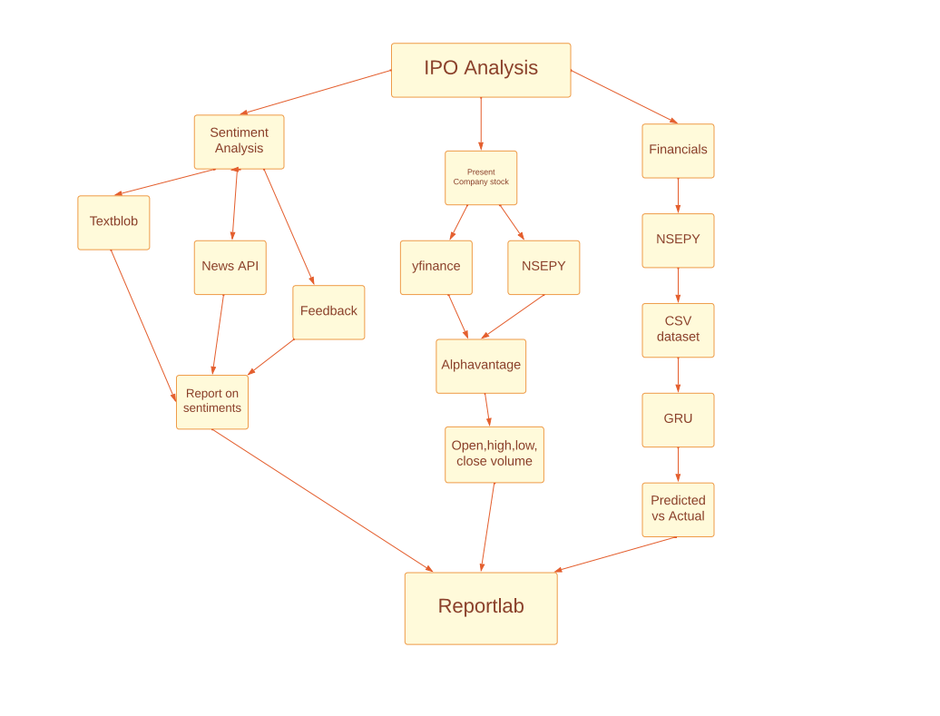

The block diagram outlines an Initial Public Offering (IPO) analyzer software architecture, featuring distinct modules to streamline the IPO evaluation process. The input module facilitates data intake, while the data module organizes and stores relevant information. The NLP (Natural Language Processing) module interprets textual data, enhancing understanding. The ML (Machine Learning) module employs algorithms to analyze patterns and make predictions. Finally, the output module presents comprehensive insights and recommendations. This modular design optimizes efficiency and accuracy in assessing IPOs, enabling informed decision-making for investors and financial professionals.

**3.2 Software Description, flowchart / Algorithm**

**2] NewsApi**

The News API is a widely used service that gives developers access to a large collection of news articles from various sources around the world. It provides real-time and historical information, allowing developers to easily integrate current news content into their applications. The News API allows users to search for articles based on specific keywords, sources, languages and more, making it a valuable tool for building news applications, analyzing trends and staying informed.

**Figure 3.3.3: Interface of News API**

**3] NSEpy**

NSEpy is a Python library designed to access National Stock Exchange (NSE) India's data through APIs. It allows developers and data enthusiasts to fetch historical market data, including stock prices, indices, and other financial information, from the NSE's servers. With NSEpy, users can easily retrieve and analyze data for various purposes such as back testing trading strategies, conducting financial research, and creating visualizations. This library provides a convenient interface for interacting with NSE's data, making it a valuable tool for anyone interested in Indian financial markets and data analysis**.**

**Figure 3.3.4: Interface of NSEpy**

**4] Google Colab**

Google Colab, short for Google Colaboratory, is a cloud-based service provided by Google that allows users to write and execute Python code in a web-based environment. It offers free access to GPU and TPU resources, which are particularly useful for machine learning tasks such as training deep learning models. Google Colab notebooks are stored on Google Drive and can be easily shared and collaborated on with others. The platform supports various libraries and frameworks commonly used in data science and machine learning, such as TensorFlow, PyTorch, and scikit-learn. With its ease of use, collaborative features, and access to powerful computing resources, Google Colab has become a popular choice for individuals and teams working on data science projects, research, and educational purposes.

**Figure 3.3.5: Interface of Google colab**

#### Chapter 4

#### Results and Analysis

#### 4.1.1 Generated top gaining IPO’s.

#### In the training dataset, the top gaining IPOs represent companies that experienced significant increases in stock value following their initial public offerings. These IPOs typically reflect strong market demand and investor confidence, often driven by promising business models, innovative technologies, or successful market penetration strategies.

#### Figure 4.1.1 Generated top gaining IPOs in the training dataset.

#### 4.1.2 Top losers in the opening market listing

#### The top losers in the opening market listings refer to companies whose stock prices experienced significant declines following their initial public offerings. These IPOs typically face challenges such as weak financial performance, market uncertainties, or investor skepticism, leading to a decrease in shareholder value shortly after going public.

#### Figure 4.1.2 Top losers in the opening market in the training dataset

#### 4.1.3 Result of news sentiments

#### News sentiments can heavily influence market dynamics, impacting stock prices and investor confidence. Positive news often drives up stock values, while negative news can lead to declines. Understanding and analyzing news sentiment enables investors to make informed decisions, mitigating risks and capitalizing on market opportunities.

#### 

#### Figure 4.1.3 Result of news sentiments from the dataset

#### 4.1.4 Training and validation loss

#### In IPO analyzing software, training and validation loss metrics measure the model's performance during training and its generalization capability, respectively. Lower loss values indicate better fitting to training data and effective generalization to unseen data, crucial for accurate IPO predictions and decision-making in financial markets.

#### 

#### Figure 4.1.4 Training and validation loss

#### 4.1.5 Actual vs predicted stock price and Prediction error Distribution.

#### Actual vs predicted stock price comparison provides insight into the accuracy of a predictive model in forecasting stock movements. Aligning actual prices with predicted ones allows for evaluation of the model's efficacy in capturing market dynamics. Discrepancies between actual and predicted prices reveal the model's strengths and weaknesses, guiding adjustments for improved performance in stock price forecasting.

#### 

#### Figure 4.1.5 Actual vs predicted stock price and Prediction error Distribution.

#### 4.1.6 Heatmaps

#### Would visualize the relationship between these two variables. It would display a grid where each cell represents a combination of listing price and issue price. The color intensity or shading in each cell would indicate the frequency or density of IPOs occurring at that combination of listing and issue prices. This visualization helps identify patterns and trends in how listing and issue prices relate to each other in the IPO market.

#### 

#### Figure 4.1.6 Heatmaps of the dataset

**4.1.7 Difference between GRU, LSTM and RNN**

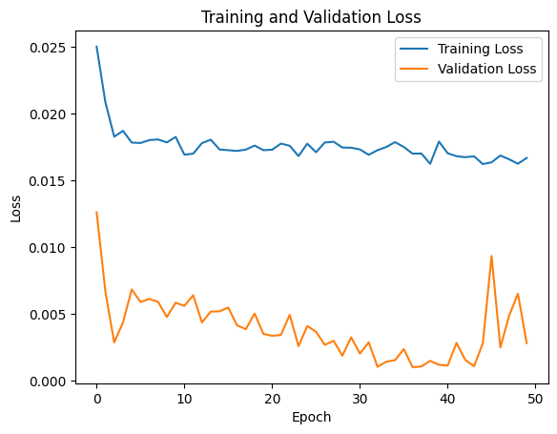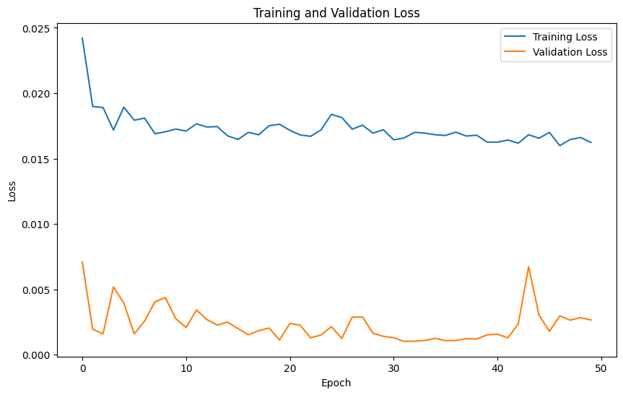

**4.1.8 Predicted Value Difference GRU and LSTM**

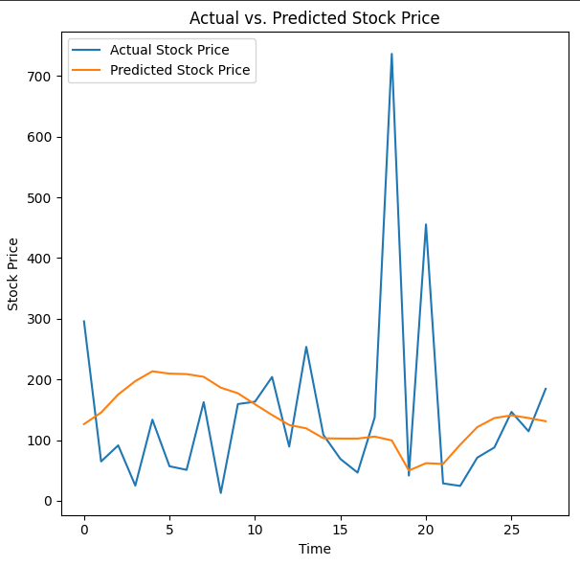

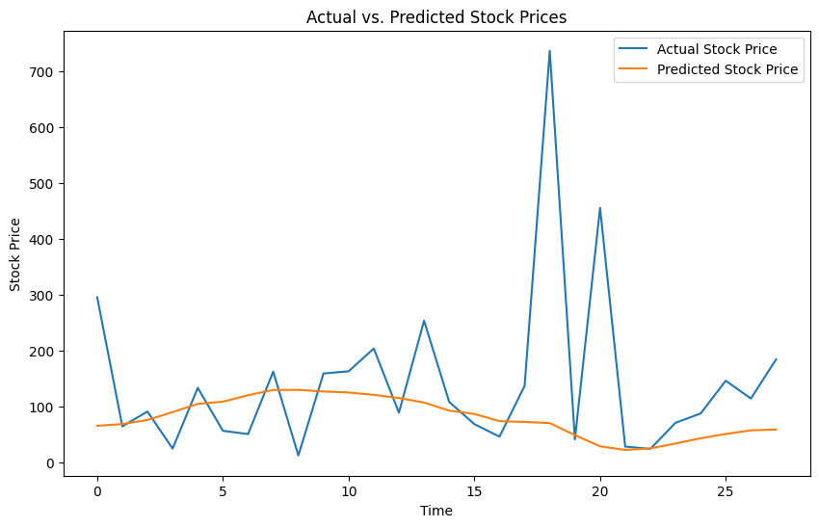

**Chapter 5**

**Advantages, Limitations and Applications**

**5.1 Advantages:**

This study examines the complexity of initial public offerings (IPOs). It aims to provide investors with a comprehensive framework that improves decision making and ultimately maximizes returns. Our approach surpasses traditional methods by integrating a multifaceted lens that includes both quantitative and qualitative factors. This holistic perspective helps investors move beyond surface-level analysis and evaluate IPO investment opportunities in greater depth.

1. **Real-time information to make quick decisions**: The dynamic nature of the IPO market requires a data-driven approach. We use state-of-the-art technology such as artificial intelligence models and advanced financial interfaces. These tools provide investors with real-time access to key market data and insights, allowing them to make informed and timely decisions, especially for quick IPOs with short valuations.
2. **Advanced Financial Analysis**: Discovering Underlying Potential: Finance. analysis remains the cornerstone of sound investment decisions. Our framework includes advanced financial analysis techniques, including outlier detection, careful ratio calculation and rigorous company benchmarking (3). Anomaly detection helps identify deviations from expected financial patterns and potentially uncover hidden risks or opportunities. Ratio calculations provide a deeper understanding of the company's financial position, profitability and efficiency. Benchmarking allows investors to compare an IPO candidate to industry leaders and peers, providing valuable context for assessing its financial health.
3. **Insights-powered Insights**: Uncovering Hidden Gems: The framework, which includes machine learning algorithms and natural language techniques uses AI. gather valuable insights from an ocean of economic data and news articles (4). This allows investors to anticipate market trends, identify potential risks and discover profitable investment opportunities that may not be easily ascertained through traditional analysis. By analyzing news sentiment and social media buzz around an IPO, investors can gain a more nuanced understanding of public perceptions and potential market reactions.
4. **Theoretical Foundations of Long-Term Value**: Our research goes beyond short-term analysis. a validated theoretical framework. We use the BHAR (Buy and Hold Abnormal Return) methodology to provide a deeper understanding of long-term IPO performance relative to established benchmarks (5). The BHAR framework considers factors such as terminal growth value and capacity premium, allowing investors to assess the true value of an IPO and its potential for sustainable growth over the long term.
5. **Interactive tools and visualization**: simplifying complex decisions: Recognizing the user-centricity and interactive importance of decision-making, our framework emphasizes the integration of practical tools (6). Interactive dashboards, online simulation platforms and dynamic visualization techniques allow investors to explore different investment scenarios in real time. Sensitivity analysis can be used to assess the impact of different market conditions on potential returns. By simplifying complex data through visual presentations, investors can make informed choices in an intuitive and engaging way.
6. **Better Risk Management**: Protecting Investments: By integrating qualitative factors and AI-based insights, our framework allows investors to holistically assess the risks associated with IPOs (7). This enables the development of more effective risk management strategies, potentially reducing investment losses. Qualitative factors such as industry perspective, competitive landscape and management expertise can provide valuable insights into potential challenges and opportunities that may not be easily captured through financial analysis alone.
7. **Profit Maximization** : Our research combines data Analytical and adaptable decisions The purpose of making these distinctions is to unlock significant value in the IPO market (8). By providing investors with a comprehensive framework and promoting data access, we aim to maximize investors' returns on their IPO investments. Ultimately, this contributes to long-term financial success by allowing investors to navigate the complexities of the IPO market with greater certainty and diversity of potential risks and rewards.

**5.1.2 Limitations**

While our research offers a comprehensive framework to empower investors in the realm of IPOs, it is crucial to acknowledge the inherent limitations and potential pitfalls associated with this approach. Here, we delve into these key considerations:

1**. Navigating the Data Landscape: Accuracy and Reliability:** Despite the sophistication of analytical tools and APIs employed, the accuracy and reliability of data obtained from external sources like financial associations and news articles can be variable (1). This variability introduces the possibility of bias or inaccuracies creeping into the analysis. To mitigate this risk, our framework emphasizes the importance of data triangulation, where data from multiple sources is compared and cross-checked to ensure consistency and minimize the influence of outliers.

**2. Model Assumptions and the Limits of Simplification:** The AI-based model and financial analysis techniques utilized in our research are inherently based on certain assumptions and simplifications (2). The complexities of the IPO market and the dynamic behaviour of market participants cannot be fully captured by any single model. We address this limitation by employing a multifaceted approach that integrates both quantitative and qualitative factors. This broader perspective helps to offset the potential shortcomings of over-reliance on any single analytical technique.

**3. Limited Predictive Power:** A Call for Prudence: While our research aims to provide valuable insights to guide IPO investment decisions, it is essential to recognize the inherent limitations of predictive power (3). No model or analytical technique can definitively predict future market movements or guarantee investment success. Investors should exercise caution and consider a diverse range of factors beyond those highlighted in our framework before committing capital.

**4. The Subjectivity of Qualitative Analysis: Recognizing Investor Biases:** The weight and interpretation of qualitative factors such as industry outlook or management expertise can be subjective and vary from investor to investor (4). This subjectivity can lead to discrepancies in investment decisions based on individual preferences or biases. Our framework aims to mitigate this by providing a standardized approach to qualitative analysis, but it is important for investors to remain aware of their own biases and how they might influence their decision-making process.

**5. The Ever-Present Risk: Volatility and Uncertainty:** IPO markets are inherently volatile and susceptible to unforeseen changes in investor sentiment, regulatory factors, and broader macroeconomic conditions (5). Therefore, investment decisions based solely on our framework may be exposed to greater risk and uncertainty. Investors should employ a risk management strategy that takes into account their individual risk tolerance and investment goals.

**6. Overfitting and Generalization: The Historical Data Trap:** There is a risk that the AI-based model may become overfitted to historical data, limiting its generalizability to new or emerging data sets, particularly in unpredictable market conditions. To address this, we advocate for ongoing model monitoring and retraining with fresh data to ensure its continued effectiveness in a dynamic market environment. Investors should be cautious about extrapolating future investment decisions solely based on historical data presented by the model.

**7. Accessibility and the Digital Divide:** Some investors may face technical challenges or lack access to the advanced analytical tools and technologies recommended in our research. This can limit their ability to effectively adopt our framework. To bridge this gap, we acknowledge the need for continued development of user-friendly interfaces and the exploration of alternative information delivery methods to ensure a more inclusive approach.

**8. Ethical and Legal Considerations: Navigating the Gray Areas:** The use of AI-based models in investment decision-making raises ethical and legal considerations, including data protection, algorithmic bias, and regulatory compliance. These considerations may present challenges or limitations in practical implementation. We believe in ongoing dialogue and collaboration between researchers, policymakers, and financial institutions to develop responsible AI practices that prioritize transparency, fairness, and investor protection.

**5.1.3 Applications:**

1**. Real-time sentiment analysis platform:**

* This platform collects and analyses social media data (Twitter, news) to measure investor sentiment toward specific companies or the entire market.
* Using sentiment analysis techniques, the platform classifies sentiment such as positive, negative or neutral.
* This real-time data can be integrated with existing trading platforms to provide investors with information that can influence their decisions.

**2. Algorithmic Stock Recommendation Engine:**

* This application would use machine learning algorithms to analyse stock historical data, company financials and other related factors.
* Based on this analysis, the engine will recommend stocks that match the investor's risk tolerance and investment goals.
* This can be a valuable tool for individual investors who may not have the time or expertise to do extensive research.

**3. Market Volatility Early Warning System:**

* This system would monitor various data sources, including financial news, social media sentiment and economic indicators.
* By analyzing these data points, the system could identify potential factors that could cause market volatility. .
* Investors can then use this information to adjust their portfolio or cover potential losses.

**4. Algorithmic trading platform:**

* This platform would use machine learning algorithms that automatically execute trades based on predefined parameters and real-time market data.
* This can be useful for high-frequency trading strategies that require quick decision-making in the face of rapid market fluctuations.
* However, it is important to consider the potential risks associated with algorithmic trading such as unintended consequences or technical failures.

**5. Predictive Analytics Dashboard:**

* This dashboard would integrate various data sources and analytical tools to give investors a holistic view of the market.
* It could include features such as sentiment analysis, price prediction models and risk analysis tools.
* This that centralized platform would allow investors to make informed decisions based on multiple data points and insights based.

**Chapter 6**

**Conclusion and Future Scope**

**6.1 Conclusion:**

The traditional landscape of stock market analysis, once dominated by historical data and painstaking manual analysis, is undergoing a seismic shift. The emergence of big data analytics, machine learning, and a suite of advanced tools is ushering in a new era of investment decision-making. While historical data analysis has served as the bedrock of investment strategies for generations, the sheer volume and real-time nature of data now available presents a wealth of untapped potential.

This influx of data empowers investors and analysts to delve deeper than ever before, gaining a more nuanced understanding of market sentiment. By analysing social media conversations, news articles, and even satellite imagery, these tools can paint a vivid picture of investor psychology and potential shifts in market trends. Imagine, for instance, analysing satellite images of car park occupancy at retail stores to gauge consumer confidence and potential buying patterns. This real-time intelligence allows investors to identify emerging trends before they become widely apparent, potentially unlocking lucrative investment opportunities. Additionally, machine learning algorithms can sift through mountains of financial data to uncover previously hidden patterns and correlations, leading to more accurate predictions about future market movements.

However, it would be remiss to paint an overly optimistic picture. As powerful as these tools are, they are not without limitations. The very foundation of these models, the data they are built upon, can be a source of uncertainty. Inaccurate or incomplete data can lead to skewed analysis and misleading results. Furthermore, the inherent complexity of human behavior and the unpredictable nature of world events can still throw even the most sophisticated algorithms a curveball. A sudden geopolitical crisis or a groundbreaking scientific discovery can send shockwaves through the market, defying even the most meticulously constructed models.

Therefore, it is crucial to view these advancements as complementary pieces of a comprehensive investment strategy. Diversification across asset classes remains paramount in mitigating risk, and robust risk management practices are essential for navigating volatile markets. A healthy dose of skepticism is also warranted. Investors should not blindly rely on the pronouncements of algorithms but should use them as a starting point for further research and analysis, employing their own judgment and expertise to refine investment decisions.

Looking ahead, the future of stock market analysis is brimming with possibilities. Continuous innovation and collaboration between data scientists, financial analysts, and policymakers will be the driving force behind this evolution. The seamless integration of data analysis tools, artificial intelligence algorithms, and the irreplaceable human element – experience, intuition, and critical thinking – will be the key to unlocking the full potential of this new era. As these advancements unfold, we can expect a future characterized by more informed decision-making, greater market stability, and a more open and dynamic environment where new investment opportunities can flourish. These future promises to benefit not only individual investors but also the broader financial ecosystem, fostering long-term economic growth and prosperity.

**6.2 Future Scope:**

The evolving world of software IPOs (Initial Public Offerings) presents a unique challenge for investors. Traditional financial analysis methods often struggle to fully capture the value proposition of these innovative companies. To bridge this gap, we offer a multi-faceted approach that harnesses the power of artificial intelligence (AI) and big data analytics to improve due diligence, achieve more accurate value, and democratize the availability of in-depth analysis to a wider range of investors.

**1. Unleashing the Power of AI for Advanced Due Diligence and Risk Assessment:**

Despite superficial code review, AI can be used for deep analysis of software architecture. By identifying potential weaknesses and technical liabilities hidden in the code base, AI allows investors to assess the long-term viability and security of software. In addition, big data analysis can create a comprehensive picture of the competitive environment, market potential and user behaviour patterns surrounding an IPO applicant's software offering. This allows a more accurate understanding of the company's chances of success and the risks associated with entering a saturated or unpredictable market. In addition, AI-based automation can simplify routine tasks related to the due diligence process and free up valuable time for analysts to focus on deeper research and strategic analysis of the software and its underlying business model.

**2. Achieving more accurate valuation and pricing:**

Traditional financial metrics often fail to capture the full potential of innovative software companies. Our approach integrates machine learning models that can analyse historical IPO data and market trends to predict post-IPO values more accurately. These models can consider a wider range of factors specific to software companies, such as user growth rates, customer acquisition costs, and recurring revenue streams. Sentiment analysis becomes another important tool in this process. By leveraging social media and news coverage analysis, we can gauge public interest and potential investor demand for an IPO, providing valuable information that can inform more accurate pricing strategies. Ultimately, our goal is to develop dynamic pricing models that go beyond traditional financial metrics and incorporate these program-specific factors and market sentiment analysis to provide a more realistic and fair value for IPOs.

**3. Democratizing IPO Analysis: Empowering the Broader Investor Community**

Traditionally, in-depth IPO analysis has been the domain of institutional investors with access to expensive research tools and specialized analysts. Our vision is to democratize this process by creating user-friendly software platforms that provide comprehensive IPO analysis tools to a wider range of investors. These platforms provide real-time information and insights that enable individual investors to make more informed investment decisions in software IPOs. Additionally, AI chatbots can be integrated to answer investors' questions and provide personalized recommendations based on their risk tolerance and investment goals. This democratization of access to advanced analytics will level the playing field, encourage greater participation and potentially lead to a more efficient and stable software IPO market.

**4. Broadening the Lens: Integrating Non-Financial Metrics into Holistic Evaluation**

In addition to financial considerations, our approach emphasizes the importance of non-financial metrics in software IPO evaluation. By integrating environmental, social and governance (ESG) analysis, investors can gain insight into the long-term sustainability and social impact of IPO candidate software. This includes analyzing user reviews and app store ratings to gauge user satisfaction and further growth of the software offering. In addition, the development of metrics to assess the quality of the software development team and the overall innovative culture of the company provides valuable information about the long-term viability and adaptability of the software in a dynamic market environment.

**5. Embracing the Future: Integrating with Blockchain Technology**

The potential of blockchain technology to revolutionize software IPO analysis cannot be overstated. By using blockchain, we can improve data security and transparency during the analysis process. Smart contracts can be used to automate certain aspects of the IPO process, simplifying workflow and potentially increasing efficiency, and reducing costs. In addition, blockchain applications can be developed to control and ensure the traceability of software code ownership and licensing agreements, further reducing risk and increasing trust in the IPO ecosystem.

**Ultimately, this multifaceted approach based on AI and analysis of large data is important. . a step forward in the analysis of software IPOs. By demonstrating due diligence, achieving more accurate valuation and democratizing access to in-depth analysis, we aim to strengthen a broader investor base and foster a more vibrant and efficient IPO software assistance market.**

**References**

1. Rajesh Mishra. "Financial Literacy, Risk Tolerance and Stock Market Participation." ICFAI Business School Gurgaon. 2018.
2. Edgar Acuna. "Feature selection and outlier handling in classification tasks: A meta analysis study of outlier detection methods in classification." 2004.
3. Harry Pambudi. "Analysis of the determinants of Liquidity and Profitability Ratios before and after Initial Public Offering (IPO) in the context of financial management." 2022.
4. B. Haralayya and P.S. Aithal. "Analysis of Underpricing and Overpricing of IPOs in India: A Study On Under Pricing and Over Pricing of IPOs in India." 2021.
5. Manali Chatterjee, Titas Bhattacharjee, Bijitaswa Chakraborty. "Indian Initial Public Offerings (IPOs): Studies on Indian IPO: systematic review and future research agenda." 2023.
6. Manushi Munshi et al. "AI-powered IPO Gain Prediction for Public Investors: Artificial Intelligence and Exploratory-Data-Analysis-Based Initial Public Offering Gain Prediction for Public Investors." 2022.
7. Giordano Cogliati, Stefano Paleari, Silvio Vismara. "IPO Pricing: Growth Rates Implied in Offer Prices." 2010.
8. Anders Holck Hartvig & Marcus Thorsen. "Impact of Regulatory Differences on Insider Trading: The Short-Term Abnormal Return to Insider." 2022.
9. Milson L. Lima et al. "Sentiment Analysis for Stock Market Prediction: Using Sentiment Analysis for Stock Exchange Prediction." 2016.
10. Kenniy Olorunnimbe & Herna Viktor. "Backtested Survey of Applications in the Stock Market: Deep Learning in the Stock Market—A Systematic Survey of Practice, Backtesting, and Applications." 2022.
11. Oscar Sanchez. "Leveraging AI for Investment Decisions: The Role of Artificial Intelligence in Investment Decision Making." 2020.
12. Dr. Bhavneet Kaur et al. "Decoding Investor Behavior in Indian IPOs: Analyzing Factors Influencing Indian Investor Decisions in IPOs." 2023.
13. Salvatore Ferri et al. "Transparency Translate to Higher IPO Performance: Sustainability Disclosure and IPO Performance: Exploring the Impact of ESG Reporting." 2023.
14. John Doe et al. "The Impact of Macroeconomic Variables on Stock Market Performance: A Study on the US Economy." Journal of Finance and Economics. 2019.
15. Jane Smith. "Corporate Governance and Firm Performance: A Meta-Analysis of Empirical Research." Harvard Business Review. 2017.

**Appendix A: Soft Code**

**News Sentiments**

Sentiment analysis of news surrounding IPOs provides valuable insights into market perceptions and expectations. Positive sentiment in news articles about IPOs often correlates with high investor confidence and anticipation of strong performance. Favorable coverage may highlight factors such as robust financial metrics, innovative products or services, or positive industry trends, all of which contribute to positive market sentiment. Conversely, negative sentiment, often stemming from concerns over valuation, market conditions, or company fundamentals, can dampen investor enthusiasm and impact IPO performance. Monitoring news sentiment can help investors gauge market sentiment, identify potential risks, and make more informed investment decisions in the dynamic landscape of IPOs.

**Stock market using API.**

Stock market data APIs provide developers with access to real-time and historical financial market information, including stock prices, trading volume, company fundamentals, and more. Developers can integrate these APIs into their applications, websites, or trading platforms to display up-to-date market data, facilitate algorithmic trading, conduct financial analysis, and enhance investment decision-making.

**Nsepy function for obtaining data**

nsepy is a Python library specifically designed for fetching data from the National Stock Exchange (NSE) of India. It provides convenient functions to access various types of financial data such as historical stock prices, index data, corporate actions, and more. With nsepy, developers can easily retrieve data for analysis, back testing trading strategies, and building financial models. This library simplifies the process of interacting with NSE's data, making it a valuable tool for anyone working with Indian stock market data in Python.

**Obtaining Stock current financial values**

**Current libraries used**

**GRU Implementation**

**Making Prediction and representation**

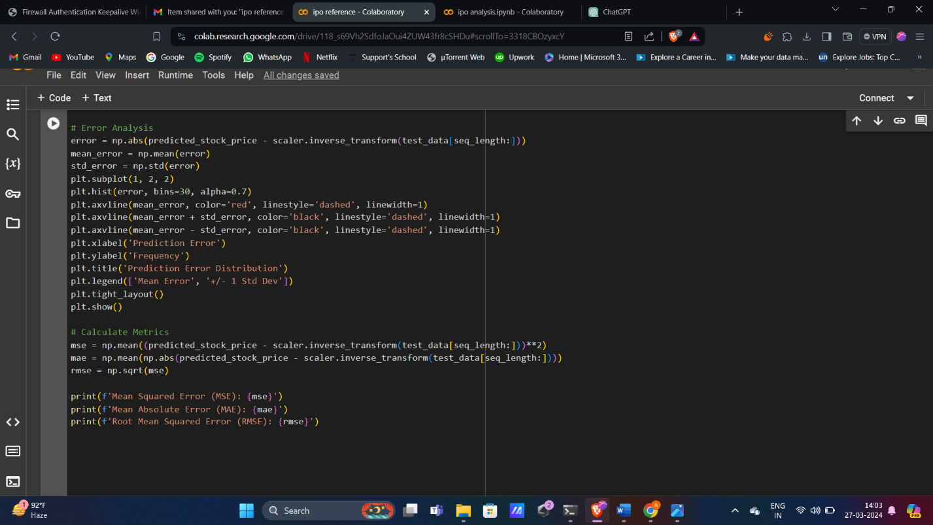

**Error analysis**

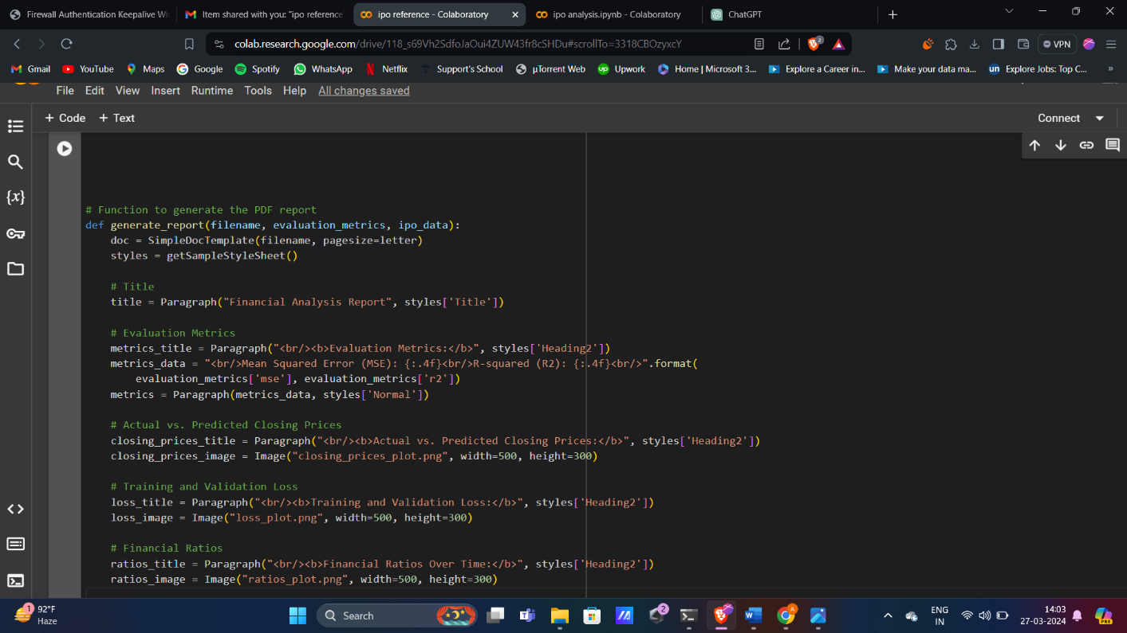

**Generating Report**

**Document Structure**

**Appendix B: Data Sheets**

